Section 9.1 - Solve Quadratic Equations by Square Root Property

Example - Solve:

Square root property
If x² = k, then
or , in other words, x =

Solve: x² - 50 = 0

Solve 3y² = 108

Solve: x² + 1 = 0

There is no real number that is a solution to this equation. We will introduce:

Working with complex numbers - standard form is a + bi, where a and b are real numbers
Simplify i²

Simplify: (3 + 4i) + (1 - 2i)

Simplify: (2 + i)(3 - 2i)

Solve: x² + 72 = 0

Solve
Example - solve: 4(y - 7)² = 48

Solve: 3(a - 3)² = 54

Solve:

Solve:

Solve: 5(a - 5)² + 4 = 104

Solve: (2x - 3)² = -12

Example - solve:

Solve: 16n² + 40n + 25 = -4
Section 9.2 - Solve Quadratics by Completing the Square

In the previous section, we were able to use the square root property to solve a quadratic so long as the left side is a perfect square. In this section, we see how to cause this to happen

Binomial squares pattern:
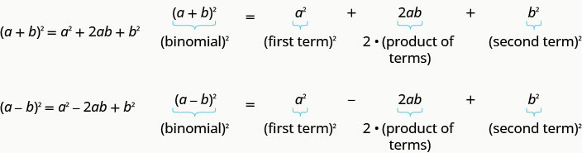
Fill in the blank to 'make' a perfect square, then factor

x² + 6x + ____ =

x² - 26x + ____ =

Example: Solve x² + 8x = 48

Solve: x² + 4x = 5
Solve: x² + 4x = -21

Solve: z² + 8z = -19

Solve: y² - 18y = -6
Solve: x² + 10x + 4 = 15

Solve: n² = 3n + 11

Solve: (x - 3) (x + 5) = 9
Example - Solve: 3x² - 12x - 15 = 0

Solve: 2x² - 3x = 20

Solve: 3x² + 2x = 4
Section 9.3 - Solving Quadratics Using the Quadratic Formula

We can now solve the generic quadratic equation: ax² + bx + c = 0

(You don't need to be able to do this, but it is worth seeing where this formula comes from)

The solutions to ax² + bx + c = 0 are given by
The quadratic formula:

Example - solve: 2x² + 9x - 5 = 0
Be sure to write down the formula each time to aid with memorizing it

Solve: x² - 6x = -5

Solve: 2x² + 10x + 11 = 0 (be sure to simplify the radical)

Solve: 3p² + 2p + 9 = 0 (non-real solutions)
Solve: x(x + 6) + 4 = 0

Solve:

Solve: 4x² - 20x = -25
The discriminant is the contents of the radical, or b² - 4ac

You can determine the type and number of solutions by just this value. If the discriminant is:
- positive, then you will have 2 real solutions
- zero, then you will have 1 real solution
- negative, then you will have 2 non-real solutions

Determine the number of solutions to each equation

3x² + 7x - 9 = 0

5n² + n + 4 = 0

4r² - 20r + 25 = 0

Methods to solve a quadratic
- Factoring - this can be very quick
- Square root property, if it fits the form ax² = k or a(x - h)² = k
- Quadratic Forumla for anything else
Section 9.6 - Graph Quadratic Equations Using Properties

Quadratic functions are of the form f(x) = ax² + bx + c

The graph of f(x) = x² looks like this
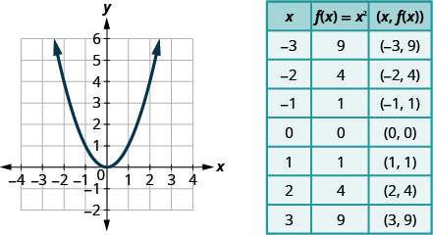

Graph: x² - 1

Graph: -x²

How can you tell if the graph of f(x) = ax² + bx + c will upward or downward.
The axis of symmetry is a vertical line about which the parabola is symmetric,
and it will be at

The vertex is the point of the parabola that lies on the axis of symmetry.

For the graph of f(x) = 3x² - 6x + 2
Find the axis of symmetry

Find the vertex

What are the points on the graph that are just to the left and right of the vertex?
ie - The points with x-coordinates of and

For the graph of f(x) = -2x² - 4x - 3
Find the axis of symmetry

Find the vertex

What are the points just to left and right of the vertex?

Intercepts are where a graph crosses an axis.
At the y-intercept, the x-coordinate is zero.
At the x-intercepts, the y-coordinates are zero.

Find the x- and y-intercepts of f(x) = x² + 4x + 3?

Graph f(x) = x² + 6x - 9 using its properties

Graph f(x) = 3x² + 12x - 12
Find the extreme (minimum or maximum) value of f(x) = 2x² - 4x - 3

The quadratic equation h(t) = -16t² + 176t + 4 models the height of a volleyball hit straight upward with velocity 176 feet per second from a height of 4 feet.
a) How many seconds will it take the volleyball to reach its maximum height?

b) Find the maximum height of the volleyball

